28/11/2016
20ml Catalyst.
Reported occasional leakage from pots. Spoke to Russell Lamming. They aren’t aware of any issues with these pots which they have used for many years.
Suggest we monitor current stock and see if it occurs on the shelf.
WHS

15/12/16

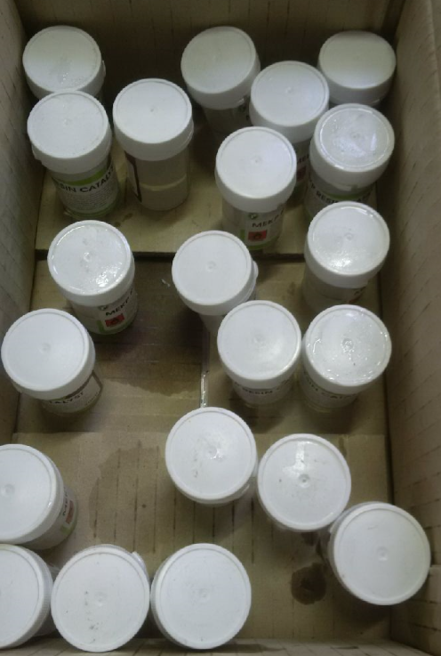
Taken 6 bottles and put in a box with one on its side.


